Evidence for Prototype (Screenshots)

Version 1
In the previous session, we created the storyboard. In this session, we are developing Prototype Version 1, which includes the baseline of the game, doors that you need to “hack”, filler quizzes, instruction. The screenshot below shows the first version of the game
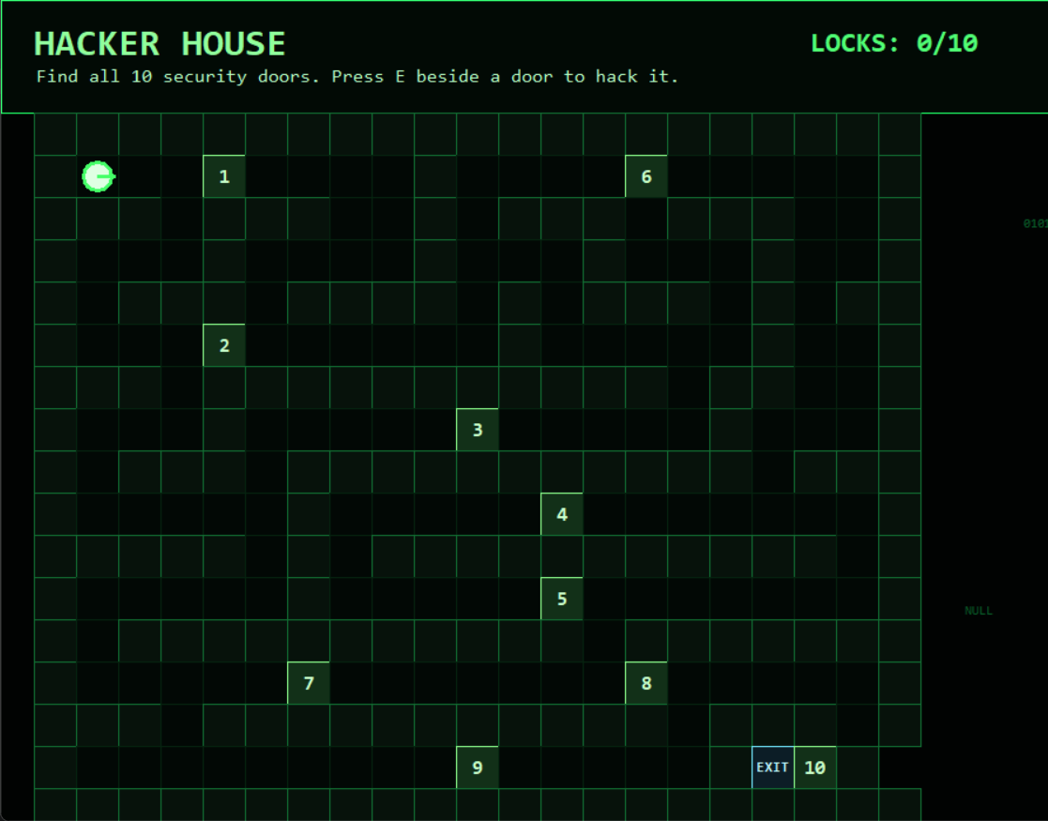
Figure 1:Hacker House Gameplay
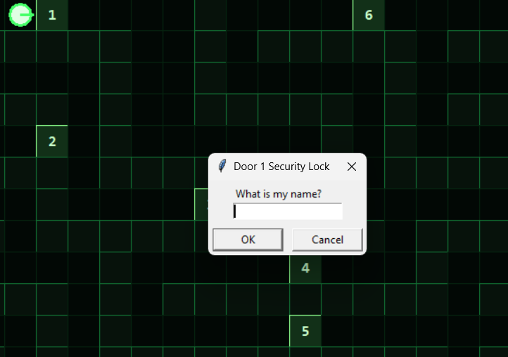
Figure 2: First Door Quiz

Version 2
In our version 2, the design of the game stayed the same but the map received an error fix, a main menu was added, a separate instruction page was created, along with a simple congrats pop up when you successfully complete the game.
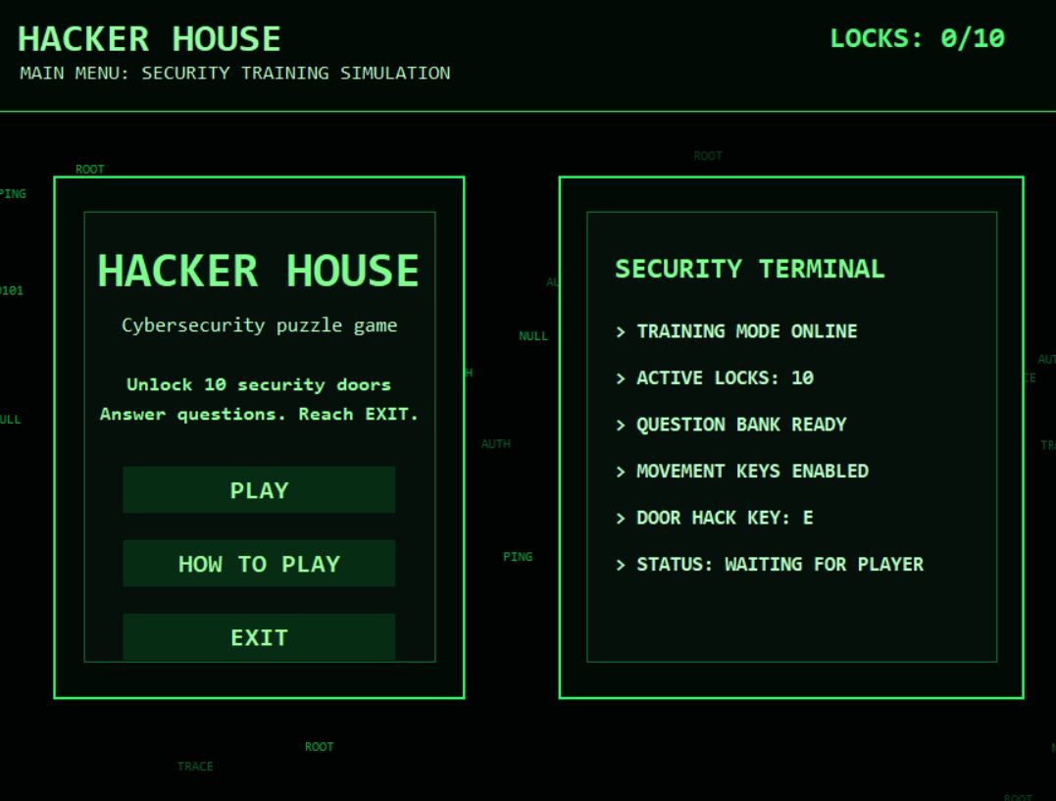
Figure 3:Hacker House Main menu
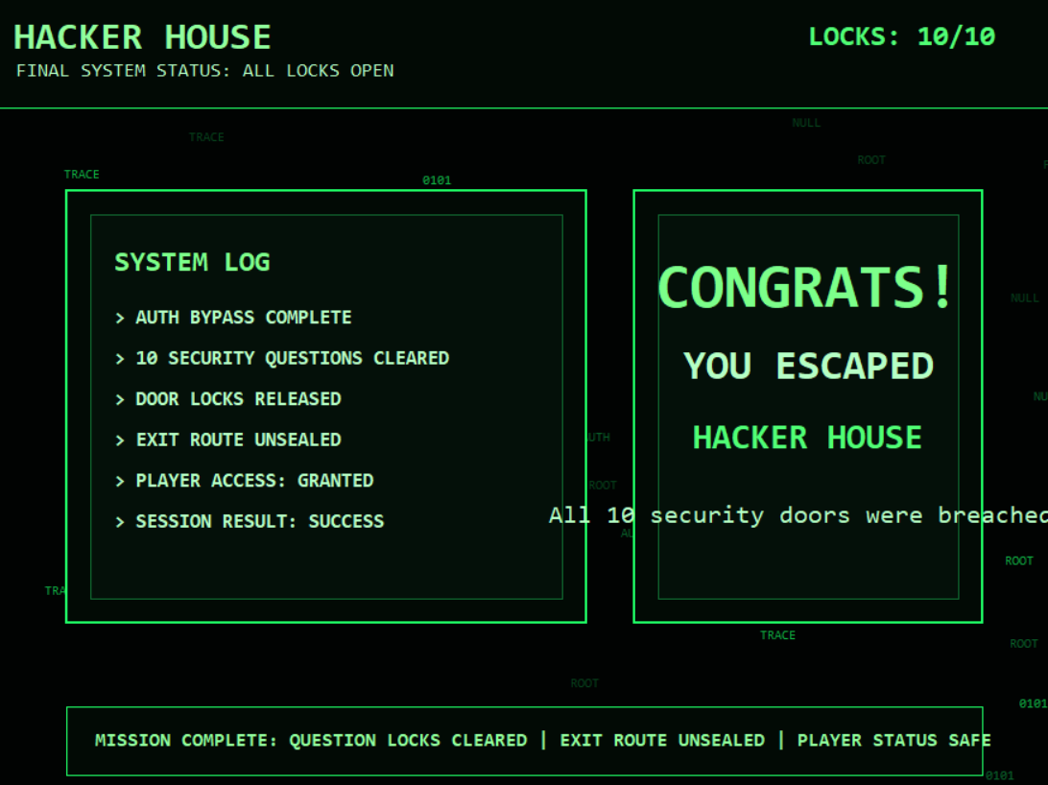
Figure 4:Completion screen
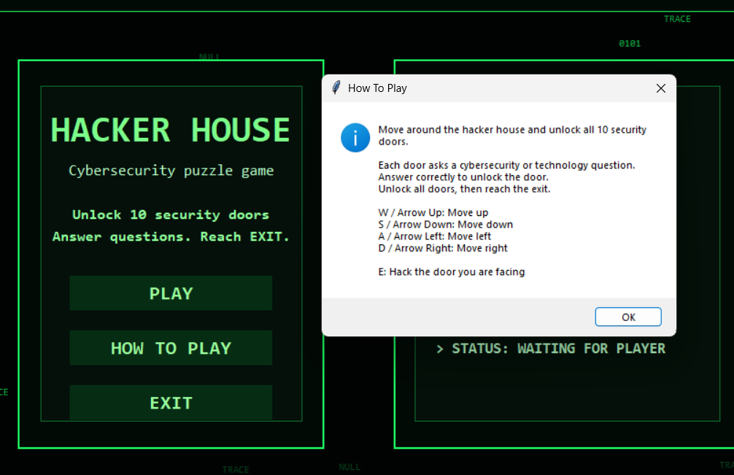
Figure 5:instruction

